Lab#13 – Implementation of HashTable

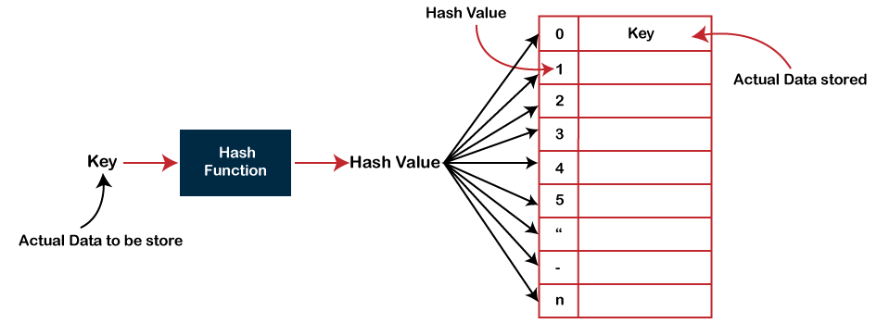

Code:

import java.util.Scanner;

/*

       This file defines a HashTable class.  Keys and values in the hash table

       are of type Object.  Keys cannot be null.  The default constructor

       creates a table that initially has 64 locations, but a different

       initial size can be specified as a parameter to the constructor.

       The table increases in size if it becomes more than 3/4 full.

   */

public class HashTable {

    static private class ListNode {

         // Keys that have the same hash code are placed together

         // in a linked list.  This private nested class is used

         // internally to implement linked lists.  A ListNode

         // holds a (key,value) pair.

       Object key;

       Object value;

       ListNode next;  // Pointer to next node in the list;

                       // A null marks the end of the list.

    }

    private ListNode[] table;  // The hash table, represented as

                               // an array of linked lists.

    private int count;  // The number of (key,value) pairs in the

                        // hash table.

    public HashTable() {

         // Create a hash table with an initial size of 64.

       table = new ListNode[64];

    }

    public HashTable(int initialSize) {

         // Create a hash table with a specified initial size.

         // Precondition: initalSize > 0.

       table = new ListNode[initialSize];

    }

    void dump() {

          // This method is NOT part of the usual interface for

          // a hash table.  It is here only to be used for testing

          // purposes, and should be removed before the class is

          // released for general use.  This lists the (key,value)

          // pairs in each location of the table.

       System.out.println();

       for (int i = 0; i < table.length; i++) {

            // Print out the location number and the list of

            // key/value pairs in this location.

          System.out.print(i + ":");

          ListNode list = table[i]; // For traversing linked list number i.

          while (list != null) {

             System.out.print("  (" + list.key + "," + list.value + ")");

             list = list.next;

          }

          System.out.println();

       }

    } // end dump()

    public void put(Object key, Object value) {

          // Associate the specified value with the specified key.

          // Precondition:  The key is not null.

       int bucket = hash(key); // Which location should this key be in?

       ListNode list = table[bucket]; // For traversing the linked list

                                      // at the appropriate location.

       while (list != null) {

             // Search the nodes in the list, to see if the key already exists.

          if (list.key.equals(key))

             break;

          list = list.next;

       }

        // At this point, either list is null, or list.key.equals(key).

       if (list != null) {

            // Since list is not null, we have found the key.

            // Just change the associated value.

          list.value = value;

       }

       else {

            // Since list == null, the key is not already in the list.

            // Add a new node at the head of the list to contain the

            // new key and its associated value.

          if (count >= 0.75*table.length) {

               // The table is becoming too full.  Increase its size

               // before adding the new node.

             resize();

          }

          ListNode newNode = new ListNode();

          newNode.key = key;

          newNode.value = value;

          newNode.next = table[bucket];

          table[bucket] = newNode;

          count++;  // Count the newly added key.

       }

    }

    public Object get(Object key) {

          // Retrieve the value associated with the specified key

          // in the table, if there is any.  If not, the value

          // null will be returned.

       int bucket = hash(key);  // At what location should the key be?

       ListNode list = table[bucket];  // For traversing the list.

       while (list != null) {

              // Check if the specified key is in the node that

              // list points to.  If so, return the associated value.

          if (list.key.equals(key))

             return list.value;

          list = list.next;  // Move on to next node in the list.

       }

        // If we get to this point, then we have looked at every

        // node in the list without finding the key.  Return

        // the value null to indicate that the key is not in the table.

       return null;

    }

    public void remove(Object key) {

          // Remove the key and its associated value from the table,

          // if the key occurs in the table.  If it does not occur,

          // then nothing is done.

       int bucket = hash(key);  // At what location should the key be?

       if (table[bucket] == null) {

            // There are no keys in that location, so key does not

            // occur in the table.  There is nothing to do, so return.

          return;

       }

       if (table[bucket].key.equals(key)) {

            // If the key is the first node on the list, then

            // table[bucket] must be changed to eliminate the

            // first node from the list.

          table[bucket] = table[bucket].next;

          count--; // Remove new number of items in the table.

          return;

       }

        // We have to remove a node from somewhere in the middle

        // of the list, or at the end.  Use a pointer to traverse

        // the list, looking for a node that contains the

        // specified key, and remove it if it is found.

       ListNode prev = table[bucket];  // The node that precedes

                                       // curr in the list.  Prev.next

                                       // is always equal to curr.

       ListNode curr = prev.next;  // For traversing the list,

                                   // starting from the second node.

       while (curr != null && ! curr.key.equals(key)) {

          curr = curr.next;

          prev = curr;

       }

        // If we get to this point, then either curr is null,

        // or curr.key is equal to key.  In the later case,

        // we have to remove curr from the list.  Do this

        // by making prev.next point to the node after curr,

        // instead of to curr.  If curr is null, it means that

        // the key was not found in the table, so there is nothing

        // to do.

       if (curr != null) {

          prev.next = curr.next;

          count--;  // Record new number of items in the table.

       }

    }

    public boolean containsKey(Object key) {

          // Test whether the specified key has an associated value

          // in the table.

       int bucket = hash(key);  // In what location should key be?

       ListNode list = table[bucket];  // For traversing the list.

       while (list != null) {

             // If we find the key in this node, return true.

          if (list.key.equals(key))

             return true;

          list = list.next;

       }

        // If we get to this point, we know that the key does

        // not exist in the table.

       return false;

    }

    public int size() {

          // Return the number of key/value pairs in the table.

       return count;

    }

    private int hash(Object key) {

          // Compute a hash code for the key; key cannot be null.

          // The hash code depends on the size of the table as

          // well as on the value returned by key.hashCode().

       return (Math.abs(key.hashCode())) % table.length;

    }

    private void resize() {

          // Double the size of the table, and redistribute the

          // key/value pairs to their proper locations in the

          // new table.

       ListNode[] newtable = new ListNode[table.length*2];

       for (int i = 0; i < table.length; i++) {

             // Move all the nodes in linked list number i

             // into the new table.  No new ListNodes are

             // created.  The existing ListNode for each

             // key/value pair is moved to the newtable.

             // This is done by changing the "next" pointer

             // in the node and by making a pointer in the

             // new table point to the node.

          ListNode list = table[i]; // For traversing linked list number i.

          while (list != null) {

                // Move the node pointed to by list to the new table.

             ListNode next = list.next;  // The is the next node in the list.

                                         // Remember it, before changing

                                         // the value of list!

             int hash = (Math.abs(list.key.hashCode())) % newtable.length;

                  // hash is the hash code of list.key that is

                  // appropriate for the new table size.  The

                  // next two lines add the node pointed to by list

                  // onto the head of the linked list in the new table

                  // at position number hash.

             list.next = newtable[hash];

             newtable[hash] = list;

             list = next;  // Move on to the next node in the OLD table.

          }

       }

       table = newtable;  // Replace the table with the new table.

    } // end resize()

 } // end class HashTable

//A Program for Testing HashTable:

 /*

    A little program to test the HashTable class.  Note that I

    start with a really small table so that I can easily test

    the resize() method.

 */

class TestHashTable {

    public static void main(String[] args){

        Scanner textIO=new Scanner(System.in);

       HashTable table = new HashTable(2);

       String key,value;

       while (true) {

          System.out.println("\nMenu:");

          System.out.println("   1. test put(key,value)");

          System.out.println("   2. test get(key)");

          System.out.println("   3. test containsKey(key)");

          System.out.println("   4. test remove(key)");

          System.out.println("   5. show complete contents of hash table.");

          System.out.println("   6. EXIT");

          System.out.print("Enter your command:  ");

          switch (textIO.nextInt()) {

             case 1:

                System.out.print("\n   Key = ");

                key = textIO.next();

                System.out.print("");

                System.out.print("   Value = ");

                value = textIO.next();

                table.put(key,value);

                System.out.print("");

                break;

             case 2:

                System.out.print("\n   Key = ");

                key = textIO.next();

                System.out.println("   Value is " + table.get(key));

                break;

             case 3:

                System.out.print("\n   Key = ");

                key = textIO.next();

                System.out.println("   containsKey(" + key + ") is "

                                             + table.containsKey(key));

                break;

             case 4:

                System.out.print("\n   Key = ");

                key = textIO.next();

                table.remove(key);

                break;

             case 5:

                table.dump();

                break;

             case 6:

                return;  // End program by returning from main()

             default:

                System.out.println("   Illegal command.");

                break;

          }

          System.out.println("\nHash table size is " + table.size());

       }

    }

 } // end class TestHashTable

Task#01

Remember in lab#03 (Implementation of array) I have given you a task, implement same task using hashTable

**Task#01:** The contact app on our phone contains a lot of contacts. In **ContactApp(class)** perform the following operations:

Display all contact

Search a contact by its name//name -> number

**Add a new contact // name, number , pos/index**

Update the contact  //name1, name2

Delete any contact //